

PSHE: How can drugs common to everyday life affect health?

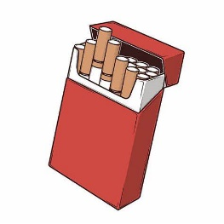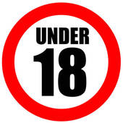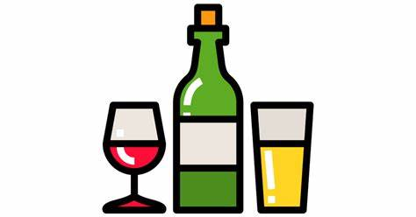

|  |
| --- |
| **Sticky Knowledge** |
| Drinking alcohol can:   * Stop your brain from working properly. It makes it more difficult to co-ordinate your arms and legs. It makes it hard for you to concentrate. * Reduce your desire to eat and dull your taste. * If drank over a long period of time, your liver might stop working properly. This disease is called cirrhosis. * Cause irritation of stomach lining and make you sick if you drink too much. * Weaken the heart’s ability to pump. This means that having a heart attack is more likely. |
| Smoking damages your lungs, can cause Cancer and breathing difficulties. It also affects your heart, makes your skin look older and can cause stomach ulcers. It can drain your energy and reduce your fitness! |
| Drugs such as alcohol and nicotine (from smoking) are highly addictive and damaging to your body. |
| Everyday medicines such as cold and flu tablets, pain killers and cough medicine should be taken only when necessary. |
| In the UK, a person who is **18** or above can buy and drink alcohol. It is legal for a person of 16 or 17 to have beer, wine or cider with a meal in a restaurant or pub, if they are accompanied by an adult. |
| In the UK, you also have to be **18** or over to buy or smoke e-cigarettes. Smoking e-cigarettes is also known as vaping. E-cigarettes, vapes or vape pens contain flavourings and other chemicals. Most contain nicotine which is an addictive drug. That means the more you have it, the more your body craves it. |

|  |
| --- |
| **Exciting Websites** |
| [What do humans need to stay healthy? - BBC Bitesize](https://www.bbc.co.uk/bitesize/topics/z9yycdm/articles/zxvkd2p)  [Keeping my body healthy - BBC Teach](https://www.bbc.co.uk/teach/class-clips-video/science-ks1-keeping-my-body-healthy/zk4dwty) |
| **Interesting Facts** |
| **5 Tips to a Healthy Body**   1. **Get up early**   Early to bed, early to rise, makes a man healthy, wealthy and wise.   1. **Get enough sleep**   Kids and teens need 10-11 hours!   1. **Exercise regularly**   Exercise for at least 30 minutes every day!   1. **Eat healthy**   Eat lots of fruit and vegetables and avoid junk!   1. **Drink plenty water**   Drink enough water to keep your body hydrated, at least 2 litres a day! |

|  |  |
| --- | --- |
| **Subject Specific Vocabulary** | |
| **Alcohol** | An ingredient in many adult beverages, like beer, wine, and spirits |
| **Cigarettes** | A thin cylinder of finely cut tobacco rolled in paper for smoking |
| **Tobacco** | Nicotine-rich leaves of an American plant, which are cured by a process of drying and fermentation for smoking or chewing |
| **e-cigarettes** | Electronic version of a cigarette |
| **Vaping** | Inhaling and exhaling vapour containing nicotine and flavouring produced by a device |
| **Medicine** | A drug for the treatment or prevention of disease |
| **Nicotine** | A toxic colourless or yellowish oily liquid from tobacco |
| **Addiction** | Being addicted to (depending on) a particular substance |
| **Substances** | For example, a drug |
| **Habit** | Something that is hard to give up |
| **Pressure** | To persuade or coerce someone into doing something |
| **Media** | Broadcasting, publishing and the internet |
| **Age restrictions** | Legal and illegal age limits |
| **Choice** | Choosing for yourself |