

|  |
| --- |
| **Exciting Websites** |
| [What is the water cycle? - BBC Bitesize](https://www.bbc.co.uk/bitesize/topics/zkgg87h/articles/z3wpp39?msclkid=de740041bff311ec83408b1c772bf7a3)  [Biomes - BBC Bitesize](https://www.bbc.co.uk/bitesize/topics/z849q6f/articles/zvsp92p?msclkid=2f5ba7c3bff411ecbbad63dbde9331cc)  [Google Maps](https://www.google.co.uk/maps?msclkid=3e6836f7bff411ec902b5148f876cf3c) |
| **Interesting Facts** |
| **The water you drink every day is the same water that has been around since the Jurassic Period!**  **There are 50 states in America!**  **The arctic circle has zero daylight hours in winter!** |

|  |  |
| --- | --- |
| **Subject Specific Vocabulary** | |
| **Equator** | An imaginary line around the globe at latitude 0° north dividing the earth into northern and southern hemispheres. |
| **Biomes** | A large geographical area which is home to certain plants and animals, specially adapted to suit the environment |
| **Climate** | The usual or average weather conditions over a long period of time |
| **Weather** | The specific atmospheric conditions on a given day including temperature and rainfall |
| **Vegetation belt** | Plant life within a certain area |
| **Human features** | Something that is built by humans and would not have existed in nature without humans |
| **Physical features** | Natural features such as rivers or hills |
| **Coastline** | The land along a coast |
| **Transpiration** | A process within the water cycle |
| **Evaporation** | The process of turning from liquid into vapour |
| **Condensation** | The conversion of a vapour or gas to a liquid |
| **Accumulation** | Gradual gathering of water |
| **Precipitation** | Rain falling to the ground |
| **Continent** | A large landmass made up of many countries |
| **Urban** | Characteristics of a town or city |
| **Rural** | Characteristics of the countryside |
| **Population** | All the inhabitants of a particular place |
| **Land use** | What land is used for e.g. retail, residential, business |
| **Region** | An area in a country without fixed boundaries |
| **Latitude** | Imaginary parallel lines which circle the globe from east to west |
| **Longitude** | Imaginary lines which run north to south across the globe from pole to pole |

**Geography: Comparing Places**

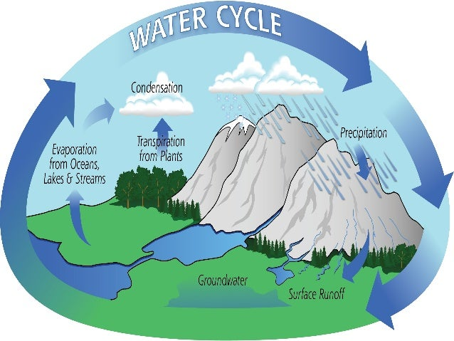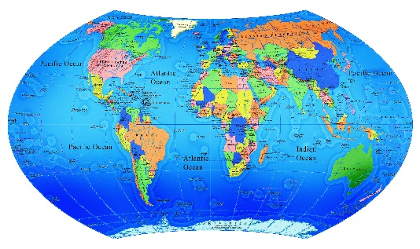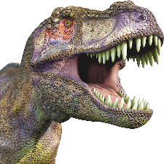

|  |
| --- |
| **Sticky Knowledge** |
| Deserts are located in places such as Australia, Africa and Mexico. |
| Rainforests are located in places such as Ghana, Brazil, Bolivia and Congo. |
| Countries have areas of different biomes such as Within these biomes, there are varied vegetation belts, which are plants growing in different parts of the world. |
| Countries all over the world have both human and physical geographical features.  Physical – naturally occurring such as oceans, lakes, mountains, rivers, coastlines and weather and climate patterns  Human – no naturally occurring such as country or region boundaries, buildings, roads and changes to river courses. Cultural aspects of areas such as language, religion, government, art and music. |
| There are 4 main parts to the water cycle process. These are evaporation, condensation, precipitation and accumulation. |
| A continent is a large land mass, usually made up of many countries. |
| Places can be classified as urban or rural. Urban has city or town-like aspects such as office buildings, being busy and noisy. Rural is the countryside, quiet and less people. |
| Latitude and longitude are imaginary parallel lines which circle the globe from east to west and run north to south from pole to pole. |
| Climate and weather are different. The climate is the usual or average weather conditions over a long period of time and the weather is the specific meteorological conditions on a given day. |