**Music:** We will learn songs for the ‘Big Sing’ event in March, and learn how to play the clarinet.

***English*:** This term we will be reading ‘Shackleton’s Journey’, which tells the story of Shackleton’s epic attempt to cross Antarctica at the beginning of the last century. This will inspire our narrative writing. We will also study ‘The Invention of Hugo Cabret’ by Brian Selznick in which we will keep an ongoing scrapbook/journal and write journalistic entries, instructions and a report about the history of film. The teaching of spelling and grammar, and reading comprehension, will be embedded within these units.

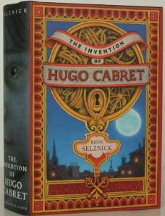

***French*:**. Healthy eating. Food & Drink: likes and dislikes. French Café



***Science:*** This term we will learn about the heart and lungs; blood circulation; and the digestive system. Towards the end of the term, we will cover further content on electrical circuits.

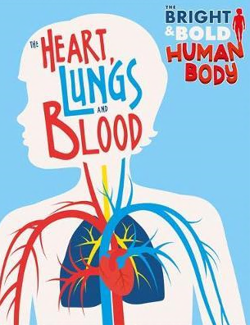

***Art/DT:*** We will learn about the work of book illustrator William Grill, and use photographs to produce artwork in a similar style, and to produce monochrome art on canvas. We will use circuits to make toys eg. a steady game or a roboduck, and design earthquake – proof structures. 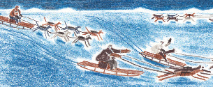

***RE:***

Understanding Christianity: The Nature of God; Creation and Science; The Fall; God’s Covenant Plan.

What difference does it make to believe in Ahimsa (Harmlessness), Grace and Ummah (Community)?

[](https://www.google.co.uk/url?sa=i&rct=j&q=&esrc=s&source=images&cd=&cad=rja&uact=8&ved=2ahUKEwjei9_Syv7mAhWyAWMBHdMJBdgQjRx6BAgBEAQ&url=https://en.wikipedia.org/wiki/Ahimsa&psig=AOvVaw0pJqPGYXQ5Yh4d3XFo0dHo&ust=1578936382372002)

***PE*:** TAG Rugby, Real PE and Cross Country.

***PSHCE***: Maintaining a healthy lifestyle for physical and mental health. This will include Bikeability training and Heartstart training.

***History:*** We will learn about Shackleton’s epic journey of survival during the Great Age of Polar Exploration, and consider a brief history of mountaineering, both as aspects of social history .

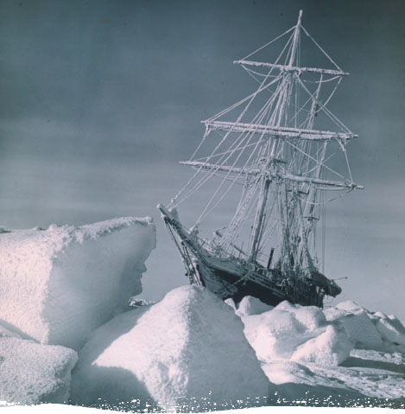

***Computing:*** multi-media presentation on illustrating a book; Computer programming

**Geography**: We will learn about the physical processes involved in the formation of mountains and volcanoes, and the occurrence of earthquakes, and the human impact of these.

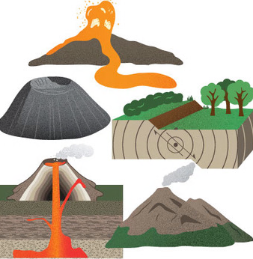

***Maths:*** Ordering numbers, place value, shape, angles, perimeter, area, mental and written methods of addition, subtraction, multiplication and division, fractions, percentages, ratio and proportion, data handling, reasoning, problem solving. Mental arithmetic and reasoning will form part of every lesson.

Dear parents and Year 6 pupils,

Here is a list of the topics that we will be covering this term. Our topic title is ‘Earth Matters: Mountains, Earthquakes & Volcanoes’..

If your child has anything related to these topics that they would like to contribute, please bring it in to school! (make sure it is named).

Mrs Paton

Many thanks, Mrs Paton

Mrs Paton

If your child has anything related to these topics that they would like to bring into school, please make sure it has their name on it.

Many thanks, Mrs Paton