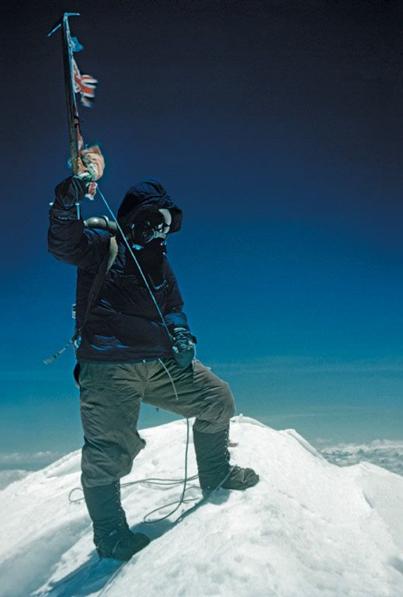
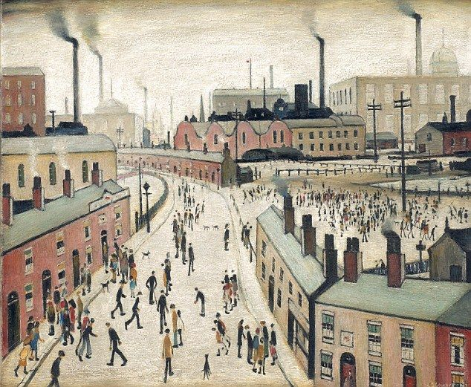
Dear children and parents of children in Year 1 (Class 2),

Welcome back to school- we hope you had a lovely Christmas break. Our main topic is ‘Famous for More than Five Minutes’.

Literacy – Our writing will be based on the story Lost and Found by Oliver Jeffers. It will involve writing character and setting descriptions, a non-chronological report and creating our own version of the story. Grammar will focus on using a wider range of conjunctions in our writing, and including questions and exclamation marks. In comprehension, we will develop our inference skills.

Maths - Counting and place value, ordering numbers, word problems, estimating, addition and subtraction, 2-D and 3-D shapes, measuring, making and using charts and tables, telling the time, finding fractions, doubling and grouping.

Science – We will be taking a close look at how animals and humans share many of the same needs, going on to see what we need to do to keep our bodies fit and healthy.

PHSE – Learning about physical health, taking care of the environment and safe use of medicines.

Computing – Creating digital content by combining our own photos and text.

Topic - (incorporating History, Geography, Art, DT and Music) – Study people who have made significant contributions both nationally and internationally: Tenzing Norgay, Mary Seacole, Vincent Van Gogh, L S Lowry. We will also find out about why our houses are called Shaw, Masefield and Elgar. We will explore features of mountains, collage and painting and will be making prayer flags as well as listening to music and discussing our ideas.

RE – What makes some places sacred? - (Christianity and Judaism) We will discuss our special places and explain why they are special, visiting Cradley Church and finding out what makes it sacred and holy. We will then visit Hereford Cathedral. We will finish off by finding out about the season of Lent and Celebrating Easter.

PE – Team games and multiskills activities including throwing, catching and jumping.

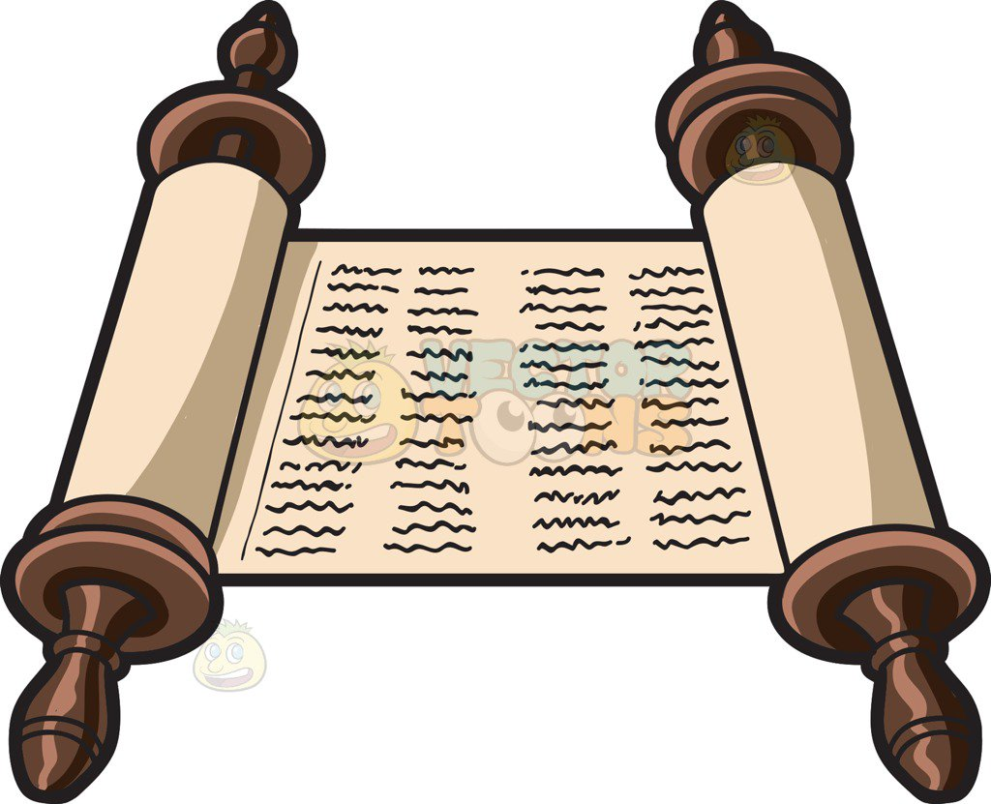
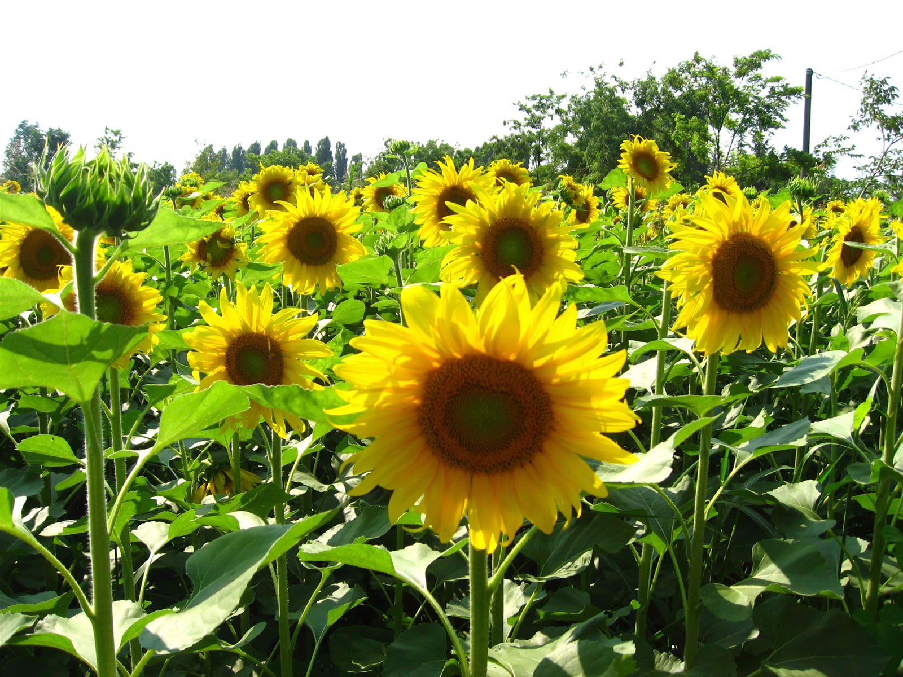
Don’t forget to keep reading every night and recording this in the back of the reading record book. PE lessons will take place on Mondays and Thursdays. There will be no Forest School sessions this term but we will be timetabling some next term. Homework will be given out on Thursday and must be handed in by the following Tuesday. If you have any queries put a note on Tapestry – this is checked every day.

With thanks, Ms George and Miss Reckling

