

|  |
| --- |
| **Exciting Websites** |
| [What is Islam? - BBC Bitesize](https://www.bbc.co.uk/bitesize/topics/zpdtsbk/articles/zrxxgwx)  [What is Ramadan? - BBC Bitesize](https://www.bbc.co.uk/bitesize/topics/zpdtsbk/articles/zjc2bdm)  [What is Eid-ul-Adha? - BBC Bitesize](https://www.bbc.co.uk/bitesize/topics/zpdtsbk/articles/zhjjf4j) |
| **Interesting Facts** |
| **Islam is the 2nd largest religion in the world, with 1.6 billion people declaring their faith in Muhammad and Allah. The largest religion? Christianity.**  **With today’s birth rates and conversions to the religion, Islam is the fastest-growing religion in the world!**  **Islam is closely related to Judaism and Christianity. This means Muslims know about Jesus, Abraham, Moses, and other great prophets from the other Abrahamic faiths.** |

|  |  |
| --- | --- |
| **Subject Specific Vocabulary** | |
| **Muslim** | A follower of the religion of Islam |
| **Islam** | The religion of the Muslims, a faith revealed through Muhammad as the Prophet of Allah |
| **Sunni** | The larger of the two main branches of Islam, which differs from Shia in its understanding of the Sunna, its conception of religious leadership, and its acceptance of the first three caliphs |
| **Shi’a** | One of the two main branches of Islam, followed by about a tenth of Muslims, especially in Iran, that rejects the first three Sunni caliphs and regards Ali, the fourth caliph, as Muhammad's first true successor |
| **Mosque** | A Muslim place of worship |
| **Prophet** | Muhammad |
| **The Five Pillars** | Five duties that every Muslim must follow in order to live a good and responsible life according to Islam |
| **Fasting** | Abstain from all or some kinds of food or drink |
| **Ramadan** | 1. The ninth month of the Muslim year, during which strict fasting is observed from dawn to sunset |
| **Pilgrimage** | To journey to |
| **Ummah** | The whole community of Muslims bound together by ties of religion |
| **Community** | A group of people living in the same place or having a particular characteristic in common |
| **Eid-ul-Adha** | The Muslim festival marking the culmination of the annual pilgrimage to Mecca and commemorating the sacrifice of Abraham |
| **Ibrahim** | **The prophet Abraham in Islam** |
| **Qur’an** | **The central religious text of Islam, believed by Muslims to be a revelation from God** |
| **Hafiz** | A Muslim who knows the Qur’an by heart |
| **Revelation** | A surprising and previously unknown fact that has been disclosed to others |

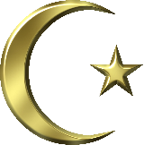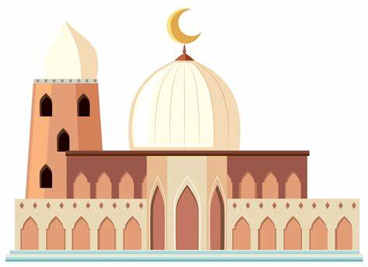

RE: What does it mean to be a Muslim in Britain today?

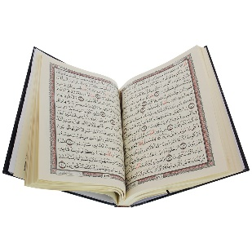

|  |
| --- |
| **Sticky Knowledge** |
| Muslims live by The Five Pillars of Islam. These are duties that every Muslim must follow in order to live a good and responsible life according to Islam.   1. Shahadah - ‘There is no god but Allah, and Muhammad is the messenger of Allah’ 2. Salat - the ritual prayer of Muslims, performed five times daily in a set form 3. Sawm - fasting from dawn until dusk during Ramadan 4. Zakah - Muslims must give a certain amount to charity 5. Hajj - the greater Muslim pilgrimage to Mecca |
| Eid-al-Adha (‘Festival of Sacrifice'), also known as the Greater Eid, is the second most important festival in the Muslim calendar. It is sometimes called ‘Big Eid’. Eid is a time to remember God’s love and kindness and it is a time of sharing. |
| Eid-al-Adha takes place at the end of the annual pilgrimage to Mecca (Hajj). During the Hajj, Muslims remember the trials of the prophet Abraham, when he was asked to sacrifice for the sake of God.  The festival remembers the prophet Ibrahim's willingness to sacrifice his son when God ordered him to. |
| Eid-al-Adha celebrates the occasion when Allah appeared to Ibrahim in a dream and asked him to sacrifice his son Isma'il as an act of obedience to God.  The devil tempted Ibrahim by saying he should disobey Allah and spare his son. As Ibrahim was about to kill his son, Allah stopped him and gave him a lamb to sacrifice instead. |