

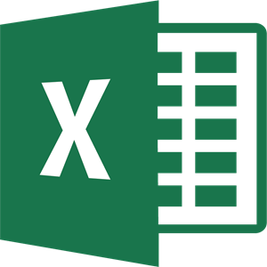

Computing: Microsoft Word, Excel and PowerPoint

 

|  |
| --- |
| **Interesting Facts** |
| **Before computers, people used a typewriter. They did not have a back space, so no mistakes!**    **The first modern computer was massive, it took up rooms and parts were put on wheels because they were so big!** |

|  |
| --- |
| **Sticky Knowledge** |
| Word processor is best used for producing large amounts of writing for an essay, fact file or letter. It has many features such as highlighting, copy and paste, font style, font size, colour, insert, text box, synonym, dictionary and line spacing. |
| Microsoft Excel is best for collating data in a spreadsheet. The table format allows you to insert both columns and rows on information, making it easy to read and analyse. It allows you to highlight the data and create charts including pie charts and bar charts to make your data more visual. You can then change the appearance of the graph such as the colours and font styles. |
| PowerPoint is best for presenting research or information. It could be used to share information about a topic, promote a product you are wanting to sell or advertising somewhere fun to go. It has many features, similar to Word, however you can create various transitions for your text and images and also add sounds, making it engaging to watch. |

|  |  |
| --- | --- |
| **Subject Specific Vocabulary** | |
| **Features** | A distinctive aspect of something |
| **Type** | Write on a computer by pressing the keys |
| **Highlight** | To hover, click and drag over text |
| **Paste** | Enter a text or image from another location |
| **Font** | A style of text |
| **Data** | Facts and statistics collected together for reference or analysis |
| **Spreadsheet** | An electronic document in which data is arranged in the rows and columns of a grid |
| **Formula** | A mathematical rule expressed in symbols |
| **Collate** | Collect, combine, compare and analyse |
| **Present** | Show or share information |
| **Chart** | A sheet of information in the form of a table, graph, or diagram |
| **Slideshow** | A presentation based on a display of images and slides |
| **Presentation** | A planned speech or talk about a piece of work is shown and explained to an audience. |
| **Effects** | The sounds and transitions used in a slideshow presentation |
| **Transitions** | A selection of movements for a slideshow |