

|  |
| --- |
| **Exciting Websites** |
| [What is a balanced diet? - BBC Bitesize](https://www.bbc.co.uk/bitesize/topics/zrffr82/articles/zppvv4j)  [Why is a healthy lifestyle important? - BBC Bitesize](https://www.bbc.co.uk/bitesize/topics/zrffr82/articles/ztsqfcw) |
| **Interesting Facts** |
| **Tips to a Health, Balanced Diet**   1. **Base your meals on starchy foods** 2. **Eat lots of fruit and vegetables** 3. **Eat more fish – including a portion of oily fish each week** 4. **Cut down on saturated fat and sugar** 5. **Eat less salt** 6. **Get active and try to be a healthy weight** 7. **Don't get thirsty** 8. **Don't skip breakfast** |

|  |  |
| --- | --- |
| **Subject Specific Vocabulary** | |
| **Design** | Decide upon the look and functioning of something |
| **Label** | Apply names or phrases |
| **Sketch** | A quick drawing with light strokes |
| **Model** | A three-dimensional representation of a person or thing |
| **Evaluate** | To assess and reflect on own work |
| **Malleable** | Able to be pressed into shape without breaking |
| **Mould** | To form an object out of malleable material |
| **Properties** | An attribute, quality, or characteristic of something |
| **Scale** | **A drawing that shows a real object with accurate sizes reduced or enlarged by a certain amount** |
| **Prototype** | A first version of a device |
|  | |
| **Recipe** | A set of instructions for preparing a particular dish |
| **Kneading** | Work moistened flour or clay into dough or paste with the hands |
| **Balanced** | Having different foods in the correct proportions |
| **Techniques** | Varied methods of doing something |
| **Hygiene** | Maintaining health and preventing disease through cleanliness |

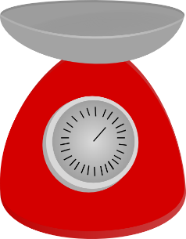

DT: World War II

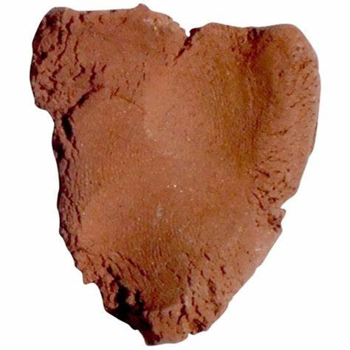

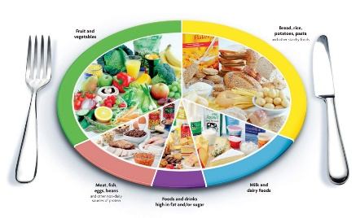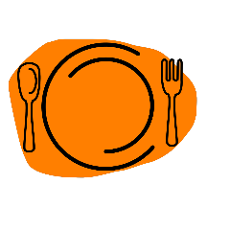

|  |
| --- |
| **Sticky Knowledge** |
| Clay is a naturally occurring material composed primarily of fine-grained minerals, which show plasticity through a variable range of water content, and which can be hardened when dried and/or fired. |
| Clay minerals are typically formed over long periods of time by the gradual chemical weathering of rocks. Clay deposits are typically associated with environments such as large lake and marine deposits. |
| Clays exhibit plasticity when mixed with water in certain proportions. When dry, clay becomes firm and when fired in a kiln, permanent physical and chemical reactions occur which, amongst other changes, causes the clay to be converted into a ceramic material. It is because of these properties that clay is used for making pottery items, both practical and decorative. |
|  |
| Eating a healthy diet is all about feeling great, having more energy, improving your health, and boosting your mood. Good nutrition, physical activity, and healthy body weight are essential parts of a person’s overall health and well-being. |
| A balanced diet, means having a range of foods but in sensible amounts, as they all contribute to a good diet. The Eat-Well plate shows these. |
| Protein builds, maintains, and replaces the tissues in your body. Protein foods include |
| Carbohydrates and starches are an important source of energy in a healthy diet. Foods with these include |
| Dairy foods are any foods that contain or are made from milk, such as yoghurt and cheese. |