**Computing:**

We will be designing and write and debug programs that support our environmental topic.

**RE:** In RE we will be thinking about what it must be like for a Muslim living in Britain studying their beliefs and traditions.

**Science:**

**(Y5)** Studying living things and their habitats, looking at life cycles and the propagation of some plants.

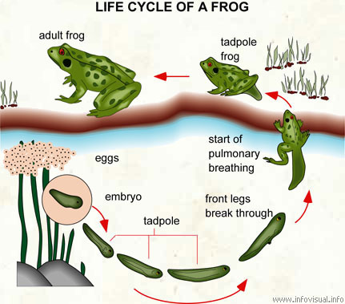

**DT and Art:** We will be creating waste sculptures from recycled materials – studying a variety of modern sculptures.

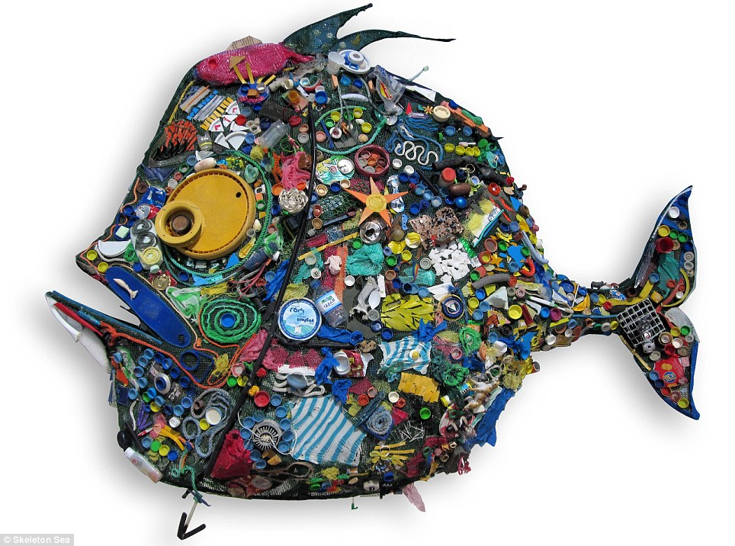

**English:** We will be studying persuasive writing, linking to our Keen to be Green topic. We will be looking at reading comprehension in depth and we will be using fiction books to help stimulate our imaginations. We will also be writing information booklets.

**History:** We will be researching the way different inventions and inventors have impacted the environment and find out how recycling has changed in Cradley and Herefordshire.

[](https://www.bing.com/images/search?view=detailV2&ccid=tgQZBF%2bP&id=9245788417A4BCF9B576615B03809D1324F9AE3A&thid=OIP.tgQZBF-PgPVyXw9a7F0TlAHaHa&q=recycling+earth&simid=608049792101057080&selectedIndex=1)

**Geography:** This will be our main focus of the term and we will be looking at human and physical geography studying climates and settlements and thinking about the impact of various activities on our planet.

We will undertake a local geographical study to investigate recycling and waste in the area.

[](https://www.bing.com/images/search?view=detailV2&ccid=904DEnTw&id=8EB2FB8F8ED226E24F2A4D888A8005D07DA58B17&thid=OIP.904DEnTwN0emW5Po33MzMwHaFj&q=Human+Geography&simid=608010424438621253&selectedIndex=40)

**PE:** In PE Year 5 will be developing basketball and dance skills while Year 4 are swimming. We will also be developing our cognitive and creative skills in Real PE.

**Music:** Year 5 will be learning to play the clarinet and learning songs for the Big Sing which we will be taking part in on 16th March at the Symphony Hall Birmingham.

**Maths:** We will be looking at negative numbers, place value, decimals, mental addition and subtraction, written addition and subtraction, co-ordinates, time, line graphsYear 4: Read and plot co-ordinates in the first quadrant. Complete polygons by giving missing point. Translate shapes in the first quadrant. Read and tell the time to nearest minute on digital and analogue clocks, use am, pm, 12-hour clock notation, and 24-hour time. Work out time intervals crossing the hour. Read and work out questions from simple timetables. Year 5: Plot points and draw polygons in two quadrants. Work out new co-ordinates after a translation or reflection. Draw a line graph and read intermediate points; Draw a conversion graph of imperial to metric units and use it to read off equivalent measures. , mental multiplication and division; written multiplication , fractions, word problems, written division, multiplication of fractions, area, perimeter and volume.

**French:** French:. Healthy eating. Food & Drink: likes and dislikes. French Café

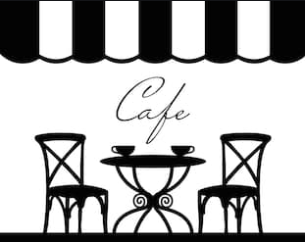

Dear Parents and Children,

Welcome back to Class 4, I hope you have had a wonderful Christmas break and feel refreshed in this New Year. Our main topic this term is Keen to be Green.

Please encourage your child to research this topic outside the classroom. If you would like to help in any way do let me know.

I would be delighted to see anything they find out about at home.

Miss Guy