**Maths:**This term we will begin my recapping addition, subtraction, multiplication and division and extending our knowledge of reasoning and problem solving. We will then move onto our Fractions and Decimals Unit. We will begin with looking at equivalent fractions before moving onto adding and subtracting fractions and then problem solving involving fractions and decimals. We will also be exploring roman numerals and negative numbers. Our unit on shape will cover 3D shapes, co-ordinates, symmetry and angles. We will also be securing our understanding of measurements through problem solving. We will also be continuing our work towards the times table test ensuring we are all confident with all times table facts and the layout of the test.

**DT and Art:** We will be creating waste sculptures from recycled materials – studying a variety of modern sculptures.

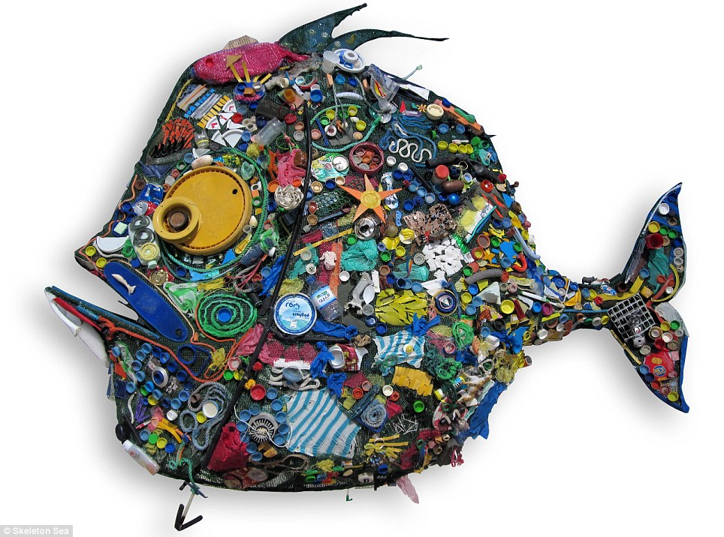

**English:** For the first half of this term will be looking at Narrative Poems. We will read various narrative poems including the work of Tony Mitton, Nick Toczek and others. We will focus on learning and performing various poems ensuring we use intonation and control the tone of our voices. We will also become experts in the features of narrative poems, understand how adventurous vocabulary can make them more exciting and finally have a go at writing our own Narrative poems. After February half term, we will be looking at ‘The Selfish Giant’ by Oscar Wilde in which the children will explore the text through a range of immersion and engagement activities and will write a range of texts, including diaries, letters, posters, reports, and their own versions (narratives).

**Computing:**

We will be designing and write and debug programs that support our environmental topic.

**RE:** In RE we will be thinking about what it must be like for a Muslim living in Britain studying their beliefs and traditions.

**Science:**

States of matter, mainly solids, liquids and gasses, which will incorporate the water cycle.

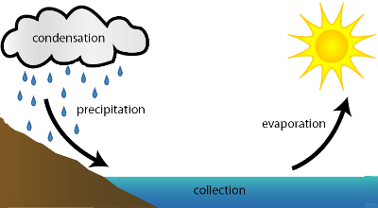

**History:** We will be researching the way different inventions and inventors have impacted the environment and find out how recycling has changed in Cradley and Herefordshire.

[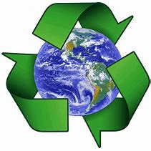](https://www.bing.com/images/search?view=detailV2&ccid=tgQZBF%2bP&id=9245788417A4BCF9B576615B03809D1324F9AE3A&thid=OIP.tgQZBF-PgPVyXw9a7F0TlAHaHa&q=recycling+earth&simid=608049792101057080&selectedIndex=1)

**Geography:** This will be our main focus of the term and we will be looking at human and physical geography studying climates and settlements and thinking about the impact of various activities on our planet.

We will undertake a local geographical study to investigate recycling and waste in the area.

[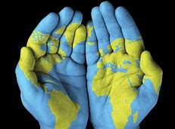](https://www.bing.com/images/search?view=detailV2&ccid=904DEnTw&id=8EB2FB8F8ED226E24F2A4D888A8005D07DA58B17&thid=OIP.904DEnTwN0emW5Po33MzMwHaFj&q=Human+Geography&simid=608010424438621253&selectedIndex=40)

**PE:** In PE Year 5 will be developing basketball and dance skills while Year 4 are swimming. We will also be developing our cognitive and creative skills in Real PE.

***French*:**. Healthy eating. Food & Drink: likes and dislikes. French Café

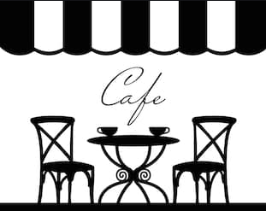

Dear Parents and Children,

Welcome back to Class 4, I hope you have had a wonderful Christmas break and feel refreshed in this New Year. Our main topic this term is Keen to be Green.

Please encourage your child to research this topic outside the classroom. If you would like to help in any way do let me know.

I would be delighted to see anything they find out about at home.

Miss Guy